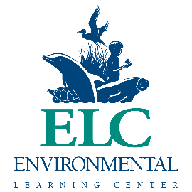

The Environmental Learning Center is hosting our annual benefit virtually in 2021! We are requesting donated items, services or gift certificates for this event. This is a wonderful opportunity to get your organization or business in front of the community, while also supporting our mission to educate, inspire and empower all people to be active stewards of the environment and their own well-being. All of the money raised benefits the Environmental Learning Center. We hope that you will consider donating in support of our mission!
Please fill out the form below with a brief description of the item donated and their retail value.
Business Name: ________________________________________________________________________
Address: _____________________________________________________________________________
Phone: _________________________________ Email: ________________________________________
Contact Person: ______________________________ Signature: ________________________________

Item and description: __________________________________________________________________________________________________________________________________________________________________________
Approximate retail value: __________________________

Item and description: __________________________________________________________________________________________________________________________________________________________________________
Approximate retail value: __________________________

Please email the completed form to info@discoverelc.org, or mail it directly to Environmental Learning Center, 255 Live Oak Drive, Vero Beach FL 32963. ATTn: Kat Redner
The Environmental Learning Center is dedicated to connecting people to the environment. Please visit our website, DiscoverELC.org to learn more about all that we offer, or feel free to call us at (772) 589-5050 ext. 102.
Thank you for your support and generosity!

